SUBMISSION TO DRAFT KILDARE COUNTY DEVELOPMENT PLAN 2023-29

CONCERNING
CHAPTER 13, LANDSCAPE, RECREATION AND AMENITY
AT
COUGHLANSTOWN WEST & HARRISTOWN
I wish to acknowledge the extensive and comprehensive draft development plan being put forward for 2023-2029 for county Kildare. It should improve the health and well-being of the population of the counties residents and attract much needed tourism in various forms. Its format and layout marries well with the “Healthy Ireland” government led initiative, in particular keeping active and ensuring everyone can enjoy good physical and mental health.
However as a resident of Coughlanstown West (fig 1) I can see a contradiction in the draft proposal for this area and the adjoining Harristown to its west (fig 2). I feel that if the plan were to go ahead in its present format it is not taking into account valuable assets the area has to offer and could lead to a loss of present scenic areas (figs 3-10), encompassing historic sites/local features (table 1) and threaten the proposed green way planned along the Sallins to Tullow disused railway line (National Transport Authority’s cycle Network Plan for the Greater Dublin Area), which runs through Coughlanstown and Harristown.
The area includes some of the highest points in Kildare offering beautiful panoramic views of the rolling country side (fig 7 & 8) which with its many quite laneways is perfect for safe secluded quite walks suitable for walkers of all abilities. The area also has two access points to banks of the Liffey where locals can swim and relax (Fig 10). Its proximity to Wicklow along with its undulating topography makes it popular with local cycling clubs.
My in-depth knowledge and appreciating of the landscape, flora, fauna and the fact that this area and the adjoining lands of Harristown is steeped in history was brought to full realisation during the pandemic when we utilised the area in full. This was not only harnessed by myself and the local residents but also by a lot of others in the greater Kildare area, (when travel restrictions were lifted) who also needed physical activity but with the escapism that the area has to offer in terms of its beauty and tranquility. I note that presently this has become a staple walk for some of those that previously didn’t come to the locality and is a testament to the areas attractiveness.
Given this my concern lies in chapter 13 of the draft plan and in particular 13.3 Landscape Character Assessment. Coughlanstown and Harristown lie in the Eastern Transition, Class 2, medium sensitivity. The description of this class is as follows “areas with the capacity to generally accommodate a wide range of uses without significant adverse effect on the appearance or character of the area”. I strongly feel that this range of uses should not include certain types of development. I note in table 13.3 of this chapter that the Eastern Transition is denoted as being of high compatibility for solar energy and medium compatibility for wind energy. If this designation were to remain in place and development of this nature were to occur, not only would it ruin the area’s present attraction for both locals and the wider Kildare population but also the possibility of the green way being harness to its full capacity and dare I say it, probably ruining any chance of it reaching realisation at all.

My recommendation is to change the development plan as follows:
- Increase the sensitivity of the above areas (fig. 1 and 2) in the Landscape Character Assessment to - class 4 Special Sensitivity. The reasoning being, to ensure that the area is protected from developments that would erode its present character, charm and scenic appeal for walkers and cyclists. Preserve the historic sites (table 1) ensuring future enjoyment of same and ring fence the potential for the proposed green way which will cut through these picturesque lands and pass by these buildings/monuments of interest.

Figure 1. Coughlanstown West.
It is located at 53° 8' 18" N, 6° 40' 50" W. Taken from townlands.ie
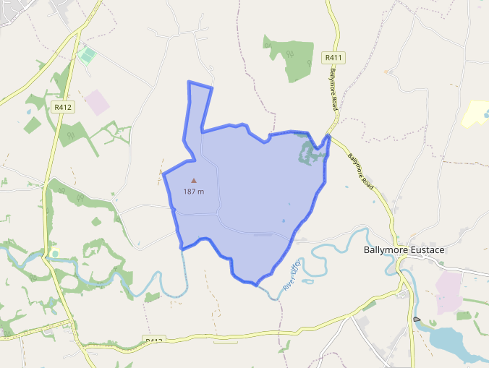
Figure 2. Harristown.
It is located at 53° 8' 18" N, 6° 40' 50" W. Taken from townlands.ie
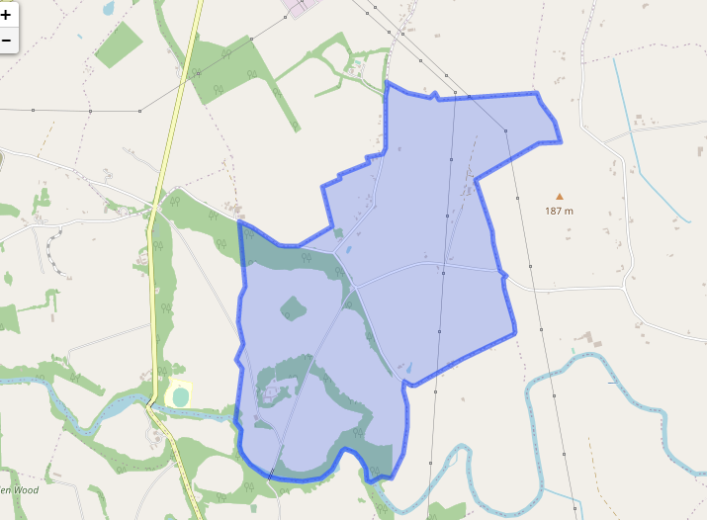

Figure 3, St James Church, Coughlanstown West
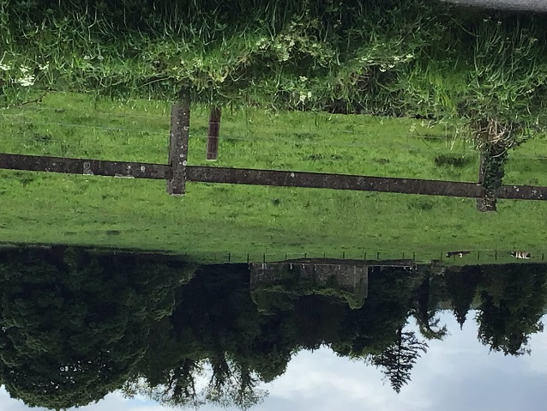

Figure 4, Coughlanstown East Cross
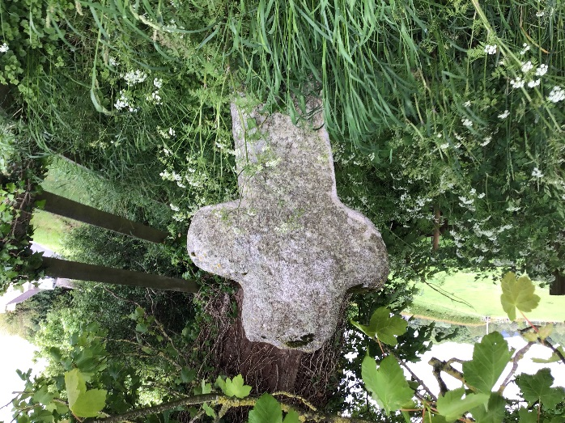
Figure 5, Stone abutments of old railway bridge, Coughlanstown West
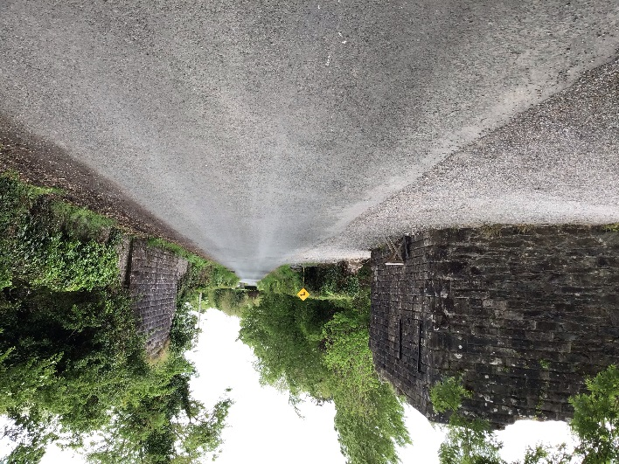

Figure 6. Stone abutments of old railway bridge, Harristown
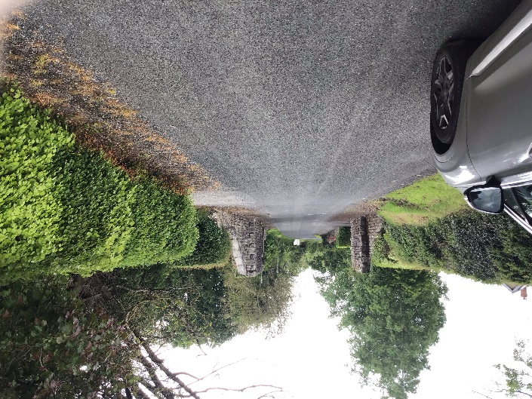
Figure 7, Mullacash Hill,
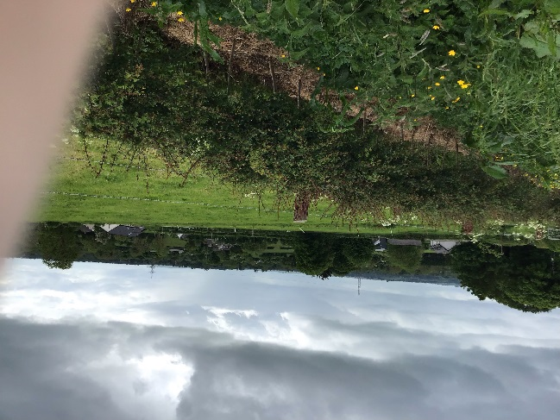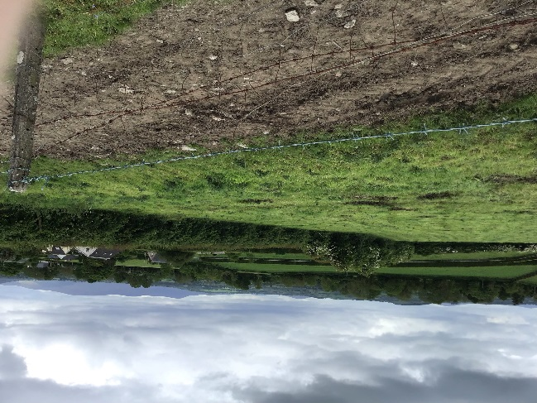
Figure 8, Harristown (Scenic laneway)
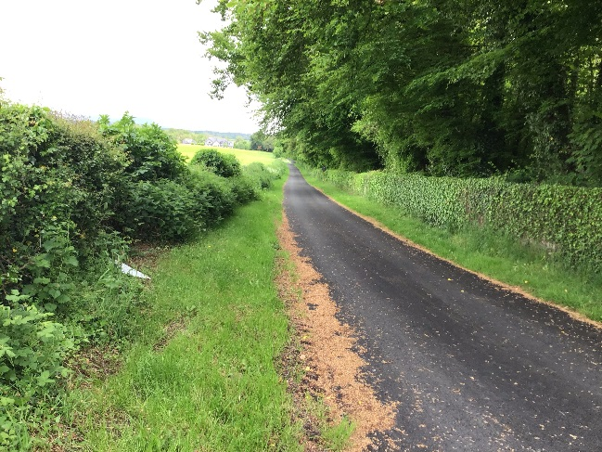

Figure 9, Coughlanstown West, Scenic Walk
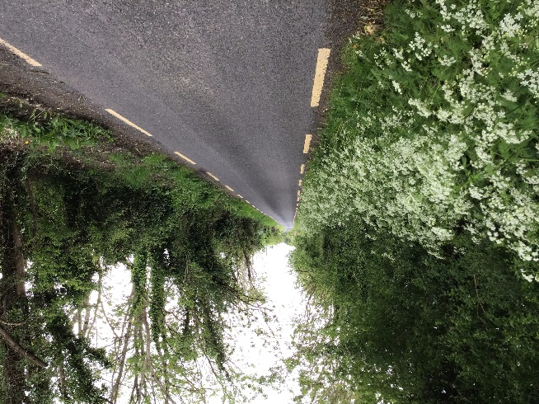
Figure 10, River Liffey from bridge on R412
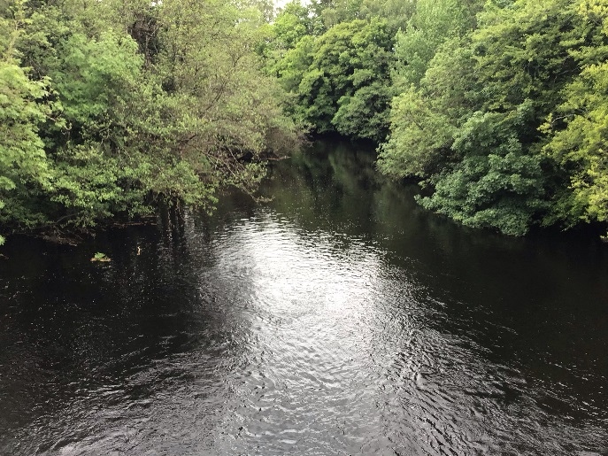
Table 1
Historic Site/local features | Location
St James Church | Coughlanstown West
Coughlanstown East Cross | Coughlanstown East
Harristown Castle | Harristown
St Patricks Church | Boundary of Harristown Demesne
Stone abutments of old railway bridge | Harristown
Stone abutments of old railway bridge | Coughlanstown West
Disused Masonry Railway Bridge over LIffey | Harristown

